AI-BASED ACCIDENT DETECTION SYSTEM
Using MobileNetV2 + LSTM for Traffic Video Analysis
Team Name: FOUREAL
Team Members:
- Harshitha A R
- Harathi Bal V
- Nagalakshmi M P
- Chaithra G D

GitHub Repository:
https://github.com/FOUREAL-Accident-Detection-System/Accident-Detection-System

ACKNOWLEDGEMENT
We sincerely Thank Jnana Setu Foundation, Our respected Rajesh Sir and Sandeep Sir trainers, mentors, and project coordinators for their guidance, technical support, and valuable feedback throughout the development of the AI-Based Accident Detection System.
We are grateful for the opportunity to work on a practical computer vision and deep learning problem and to develop the project from the initial problem definition through model development, experimentation, application integration, and prototype demonstration.
We also thank everyone who supported us during dataset preparation, preprocessing, model training, testing, web interface development, SMS integration, and project demonstration. Their suggestions and feedback helped us improve the system and understand the practical challenges involved in developing an AI-based accident detection solution.

INTRODUCTION
Road accidents require quick identification so that appropriate action can be initiated without unnecessary delay. Manual monitoring of traffic videos can be difficult and time-consuming, especially when large amounts of video need to be analyzed.
The AI-Based Accident Detection System is designed to automatically analyze traffic videos and classify them into two categories: Accident and Normal.
The system uses a deep learning approach that combines spatial and temporal information. MobileNetV2 is used to extract visual features from individual video frames, while an LSTM network analyzes the sequence of extracted features to understand how the scene changes over time.
The system is further integrated with a web interface that allows a user to upload a video, analyze it, view the prediction and confidence, obtain an approximate detection window, extract an evidence frame, and trigger an SMS alert when an accident is detected.
The final selected configuration uses:
- 10 FPS
- 160 × 160 input resolution
- 32-frame sequence length
- MobileNetV2 for feature extraction
- LSTM for temporal learning
- Accident/Normal binary classification

PROBLEM STATEMENT
Manual monitoring of road traffic videos is time-consuming and may result in delays in identifying accident events.
A single image or frame may not be sufficient to identify an accident because an accident is an event that develops over time. Therefore, the system needs to analyze a sequence of frames and learn the temporal changes occurring between them.
The problem addressed in this project is:
“To develop an automated deep-learning-based system that analyzes traffic videos and identifies whether an accident has occurred, while providing a prediction, confidence information, approximate detection time, visual evidence, and an SMS alert.”
PROJECT OBJECTIVES
The main objectives of the project are:
- To develop an AI-based accident detection system using traffic videos.
- To use deep learning for automatic Accident/Normal classification.
- To extract spatial features using MobileNetV2.
- To learn temporal patterns using LSTM.
- To determine suitable FPS, resolution, and sequence length through experimentation.
- To automate preprocessing, training, and inference.
- To reduce the possibility of data leakage.
- To evaluate the model using unseen videos.
- To analyze the generalization capability of the system.
- To integrate the model with a web application.
- To provide visual evidence of detected events.
- To integrate an SMS alert mechanism.
- To maintain the project and documentation through GitHub.

DESIGN SPACE EXPLORATION
During development, different design choices were considered to determine a suitable configuration for video-based accident detection.
The main design factors considered were:
- Frame rate
- Input resolution
- Sequence length
- CNN architecture
- Temporal model
- Classification threshold
- Computational requirements
A simple image-classification approach would consider frames independently. However, accident detection depends on changes occurring across consecutive frames. Therefore, a sequence-based approach was selected.
The system combines:
MobileNetV2 → Spatial Feature Extraction
LSTM → Temporal Pattern Learning
This combination allows the system to use both the visual information in individual frames and the movement or changes occurring across the sequence.
TRADE-OFF ANALYSIS
FPS Trade-off
Frame rate determines how many frames are extracted from a video every second.
A lower FPS reduces the amount of data and computational requirements but may miss important changes occurring between sampled frames.
A higher FPS provides more temporal information but increases the amount of processing required.
The project experimented with different FPS values, including 5 FPS and 10 FPS.
The selected value was:
10 FPS
10 FPS provided a practical balance between capturing temporal information and keeping the computational requirements manageable.
Resolution Trade-off
Traffic videos can have different original resolutions. Processing every video at its original resolution would result in inconsistent input sizes and higher computational requirements.
Therefore, all extracted frames are resized to:
160 × 160 pixels
This provides a fixed input size for the model while reducing the computational and memory requirements compared with processing the original high-resolution frames.
Sequence Length Trade-off
Sequence length determines how many consecutive frames are provided to the LSTM.
A shorter sequence contains less temporal information, while a longer sequence provides more context but requires additional computation.
The project experimented with sequence lengths including:
- 16 frames
- 32 frames
- 64 frames
The selected sequence length was:
32 frames
At 10 FPS, 32 frames represent approximately:
32 / 10 = 3.2 seconds of video information.

DATASET
The dataset contains two primary categories:
Accident
Videos containing road accident events.
Normal
Videos containing normal traffic activity without an accident.
The project materials describe the dataset as consisting of custom street/traffic videos collected from available public and collected sources.
The documented preprocessing run processed:
Dataset Information | Value
Videos processed | 146
Training sequences | 711
Validation sequences | 239
Test sequences | 219
The dataset was organized according to the two classes before preprocessing.

DATASET VERIFICATION AND PREPROCESSING
Before model training, the videos were checked to ensure that they could be processed correctly.
The preprocessing pipeline performs the following operations:
- Reads the input video.
- Obtains video properties.
- Samples frames at the selected FPS.
- Resizes frames to 160 × 160.
- Normalizes the frame data.
- Groups consecutive frames into 32-frame sequences.
- Assigns the appropriate class label.
- Stores the processed information for training and evaluation.
Automating these steps reduces manual work and provides a consistent preprocessing procedure for different experiments.

DATA LEAKAGE CONTROL
Data leakage is an important issue in video-based machine learning.
A single source video can produce many frame sequences. If sequences from the same source video are randomly divided between training and testing, the model may see highly similar information in both sets.
This can result in an artificially high evaluation performance.
To reduce this problem, the project uses video-level separation.
The general process is:
Original Videos
↓
Train / Validation / Test Assignment
↓
Sequence Generation
This ensures that sequences are generated after the source videos have been assigned to their respective datasets.
Duplicate and overlap checks were also considered during dataset preparation.
The unseen-video evaluation was kept separately from the model-development data so that it could be used to study generalization.

COMPLETE ALGORITHM PIPELINE
The complete system pipeline is:
Video Input
↓
Preprocessing
↓
Normalization
↓
MobileNetV2 Feature Extraction
↓
Global Average Pooling
↓
LSTM – 64 Units
↓
Sigmoid Output
↓
Accident / Normal
↓
Confidence / Probability
↓
Approximate Detection Window
↓
Evidence Frame
↓
SMS Alert

CNN – MOBILENETV2
The CNN used in this project is specifically:
MobileNetV2
MobileNetV2 is used as the feature extraction network.
The model uses pretrained ImageNet weights to extract useful visual information from individual frames.
The purpose of MobileNetV2 in this project is to learn spatial features from each frame.
These features can represent visual information such as:
- Vehicles
- Shapes
- Objects
- Road scenes
- Spatial relationships
- Visual changes within individual frames
MobileNetV2 was selected because it is a relatively lightweight architecture and is suitable for applications where computational resources are limited.
The CNN does not independently make the final temporal decision. Instead, its extracted features are passed to the LSTM.
LSTM – TEMPORAL LEARNING
LSTM stands for Long Short-Term Memory.
The LSTM is used to process the sequence of features produced by MobileNetV2.
This is important because an accident is a temporal event.
For example, a sequence may contain:
Vehicle movement
↓
Vehicles approaching each other
↓
Sudden movement or collision
↓
Post-accident scene
The LSTM learns relationships between these consecutive frames and captures temporal patterns associated with accident events.
The selected LSTM contains:
64 LSTM Units
The LSTM output is then passed through the dense and dropout layers before the final classification.
Component | Purpose
MobileNetV2 | Spatial feature extraction
Global Average Pooling | Converts feature maps into compact feature representation
LSTM | Temporal sequence learning
Dense Layer | Further feature processing
Dropout | Reduces overfitting
Sigmoid | Produces binary classification probability

FINAL MODEL CONFIGURATION
Parameter | Selected Configuration
CNN | MobileNetV2
Pretrained Weights | ImageNet
FPS | 10 FPS
Input Resolution | 160 × 160
Sequence Length | 32 frames
LSTM Units | 64
Dense Units | 32
Dropout | 0.3
Output Activation | Sigmoid
Classification | Accident / Normal

MODEL TRAINING
The model was trained using the preprocessed video sequences.
The training process includes:
- Loading the prepared sequences.
- Providing the sequences to the MobileNetV2 feature extractor.
- Passing extracted features to the LSTM.
- Training the classification layers.
- Monitoring validation performance.
- Saving the trained model and configuration.
The training process was automated to make repeated experiments easier and more consistent.
MODEL TUNING
Model tuning was performed by changing important parameters and comparing the resulting performance.
One of the important experiments was the sequence-length comparison.
Sequence Length | Accuracy
32 frames | 94.17%
64 frames | 93.48%
The 32-frame configuration produced the higher result among the documented configurations and was therefore selected for the final configuration.
The broader tuning process also considered FPS, input resolution, threshold, and temporal configuration.
The final selected configuration is:
10 FPS + 160 × 160 + 32 Frames
THRESHOLD TUNING
The model produces a probability value for the Accident class.
A classification threshold is used to convert the probability into a final Accident or Normal decision.
For example:
Model Output Probability
↓
Threshold
↓
Accident / Normal
Threshold tuning was used to study how the classification decision changes with different probability boundaries.
This is important because two types of errors can occur:
False Positive
A normal video is incorrectly classified as an accident.
False Negative
An accident video is incorrectly classified as normal.
The project configuration records a threshold of 0.45.
AUTOMATION AND QUALITY IMPROVEMENT
Automation was introduced to reduce repetitive manual work and make the project easier to reproduce.
The automated workflow includes:
Safety Checks
↓
Configuration
↓
Preprocessing
↓
Training
↓
Batch Inference
↓
Saved Results
The automated inference process can read input videos, preprocess them, generate sequences, run the trained model, calculate predictions, record detection information, and save the results.
GENERALIZATION
Generalization refers to the ability of a trained model to perform correctly on videos that it has not seen during training.
This is important for accident detection because real-world videos can vary in:
- Camera angle
- Lighting
- Road conditions
- Traffic density
- Vehicle types
- Video quality
- Accident patterns
- Background environment
A model may perform well during controlled experiments but may perform differently when presented with completely unseen videos.
Therefore, a separate unseen-video evaluation was performed.
TESTING ON 100 UNSEEN VIDEOS
The model was tested on 100 unseen videos.
The test set contained:
- 50 actual Accident videos
- 50 actual Normal videos
The results were:
Metric | Result
Actual Accident | 50
Actual Normal | 50
True Positive (TP) | 16
True Negative (TN) | 37
False Positive (FP) | 13
False Negative (FN) | 34
Accuracy | 53.00%
Precision | 55.17%
Recall | 32.00%
F1 Score | 40.51%
These results represent the model's performance on unseen videos and are therefore used specifically to analyze generalization.
Possible improvements include increasing dataset diversity, collecting more real-world accident videos, improving the balance between accident and normal scenarios, and testing the model under more varied environmental conditions.
WEB INTERFACE DEVELOPMENT
A web-based interface was developed to make the accident detection system accessible through a user-friendly workflow.
The general workflow is:
Upload Video
↓
Preview Video
↓
Analyze Video
↓
Backend AI Inference
↓
Accident / Normal Result
↓
Confidence / Probability
↓
Detection Window
↓
Evidence Frame
↓
SMS Status
The interface allows the user to interact with the model without directly executing the underlying inference code.
VIDEO UPLOAD AND ANALYSIS
The user can upload a traffic video through the web interface.
After uploading:
- The video is received by the backend.
- The video is processed using the selected FPS.
- Frames are resized to 160 × 160.
- 32-frame sequences are created.
- The trained MobileNetV2 + LSTM model performs inference.
- The prediction is returned to the web interface.
The interface displays the resulting classification and related information.
DETECTION WINDOW AND EVIDENCE FRAME
The model operates on a sequence of frames rather than identifying one exact instant.
Therefore, the system provides an approximate detection window based on the sequence that produces the accident prediction.
The system also extracts a genuine frame from the uploaded video around the detected sequence.
This evidence frame allows the user to visually inspect the portion of the video associated with the prediction.
The evidence frame is taken from the actual uploaded video rather than being artificially generated.
SMS ALERT INTERFACE
The system includes an SMS alert mechanism using the TextBee API.
The workflow is:
Accident Detected
↓
Backend
↓
TextBee API
↓
SMS Sent
↓
Web Status Updated
The SMS functionality was tested for actual message delivery.
The alert mechanism is intended to demonstrate how an accident prediction can be connected to an external notification system.
APPLICATION EXECUTION AND DEPLOYMENT
The project includes a FastAPI backend and a web frontend.
The backend handles:
- Video processing
- Model inference
- Result generation
- Detection information
- Evidence extraction
- SMS integration
The frontend provides the user interface for:
- Uploading videos
- Previewing videos
- Starting analysis
- Viewing prediction results
- Viewing evidence
- Checking SMS status
The project README contains the documented instructions for setting up and running the application.
The backend can be run using the documented FastAPI/Uvicorn workflow

HARDWARE AND SOFTWARE REQUIREMENTS
Hardware
Component | Specification
Processor | AMD Ryzen 5 5500U
RAM | Approximately 7.5 GB available
GPU | No dedicated GPU
Storage | Required for dataset, models and videos
Software
Software | Version / Technology
Python | 3.11
TensorFlow | 2.20.0
OpenCV | 5.0.0
NumPy | 2.4.6
Pandas | 3.0.5
Scikit-learn | 1.9.0
Backend | FastAPI
Frontend | HTML, CSS, JavaScript
SMS | TextBee API
Development Environment | Visual Studio Code
Version Control | Git and GitHub
The use of MobileNetV2 helps keep the model computationally manageable on the available

GITHUB FOLDER STRUCTURE
The important project folders and files are organized as follows:
Accident-Detection-System/
│
├── arthis backend/
│ └── Backend application and server-side logic
│
├── Frontend/
│ └── Web interface
│
├── configs/
│ └── Configuration files
│
├── scripts/
│ └── Preprocessing, inference and automation scripts
│
├── models/
│ └── Saved trained model files
│
├── results/
│ └── Evaluation and prediction results
│
├── detection_frames/
│ └── Extracted evidence frames
│
├── uploads/
│ └── Uploaded video handling
│
├── dataset/
│ └── Accident and Normal video organization
│
├── input_videos.txt
│ └── Input list for batch processing
│
├── requirements.txt
│ └── Python dependencies
│
└── README.md
└── Detailed project documentation
The exact implementation details and usage instructions are available in the README file in the repository.

FINAL RESULTS SUMMARY
The final documented configuration and important experimental results are summarized below:
Item | Result
Frame Rate | 10 FPS
Input Resolution | 160 × 160
Sequence Length | 32 frames
CNN | MobileNetV2
Temporal Model | LSTM – 64 units
Dense Layer | 32 units
Dropout | 0.3
32-frame tuning result | 94.17% accuracy
64-frame tuning result | 93.48% accuracy
Unseen Videos | 100
Actual Accident Videos | 50
Actual Normal Videos | 50
Unseen Accuracy | 53.00%
Unseen Precision | 55.17%
Unseen Recall | 32.00%
Unseen F1 Score | 40.51%
Evidence Frame | Extracted from actual uploaded video
SMS | TextBee integration with actual delivery testing

LIMITATIONS
The current system has several limitations.
- The model's performance depends strongly on the quality and diversity of the training dataset.
- Generalization to completely unseen real-world traffic conditions requires further improvement.
- Different camera angles, lighting conditions, road environments, and accident patterns can affect performance.
- The current system performs binary Accident/Normal classification.
- Detection time is represented as an approximate detection window based on the detected sequence.
- The current system is a project demonstration and is not intended to be treated as a certified safety-critical system.
- More extensive real-world testing is required before considering large-scale deployment.
FUTURE IMPROVEMENTS
Future development can focus on:
- Increasing the size and diversity of the dataset.
- Adding more real-world accident and normal traffic videos.
- Improving generalization to unseen environments.
- Performing more extensive real-world validation.
- Improving accident localization and timestamp accuracy.
- Adding accident-type classification.
- Adding accident-severity classification.
- Improving inference speed for real-time applications.
- Testing on suitable real-time hardware.
- Improving robustness under different lighting, camera angles, and traffic conditions.
- Further improving the web application and notification system.

CONCLUSION
The AI-Based Accident Detection System provides a complete video-based accident detection workflow using deep learning and computer vision.
The system combines MobileNetV2 and LSTM to use both spatial and temporal information from traffic videos. MobileNetV2 extracts visual features from individual frames, while LSTM learns temporal relationships across a sequence of 32 frames.
Through experimentation, the selected configuration was:
10 FPS + 160 × 160 + 32 Frames + MobileNetV2 + LSTM
The project also includes automated preprocessing and inference, model tuning, threshold analysis, data-leakage control, unseen-video evaluation, evidence-frame extraction, a web interface, and SMS alert integration.
The 32-frame model-tuning experiment produced an accuracy of 94.17%, while the separate evaluation on 100 unseen videos produced:
- Accuracy: 53.00%
- Precision: 55.17%
- Recall: 32.00%
- F1 Score: 40.51%
The difference between these results highlights the importance of evaluating generalization separately from controlled model tuning. The unseen-video evaluation identified generalization as an important area for further improvement.
Overall, the project demonstrates an end-to-end approach to AI-based accident detection, beginning with video input and preprocessing, continuing through deep-learning-based classification, and extending to a web interface, evidence extraction, and SMS notification.
The GitHub repository and its README provide the accompanying implementation details, setup instructions, experiments, and project documentation.

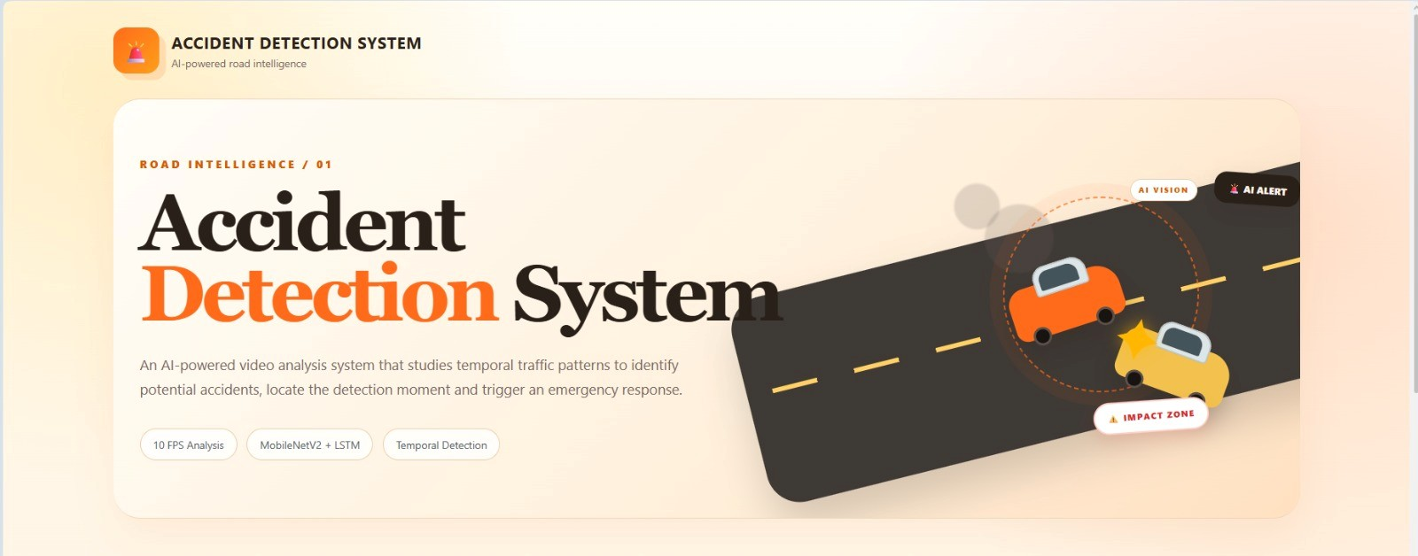

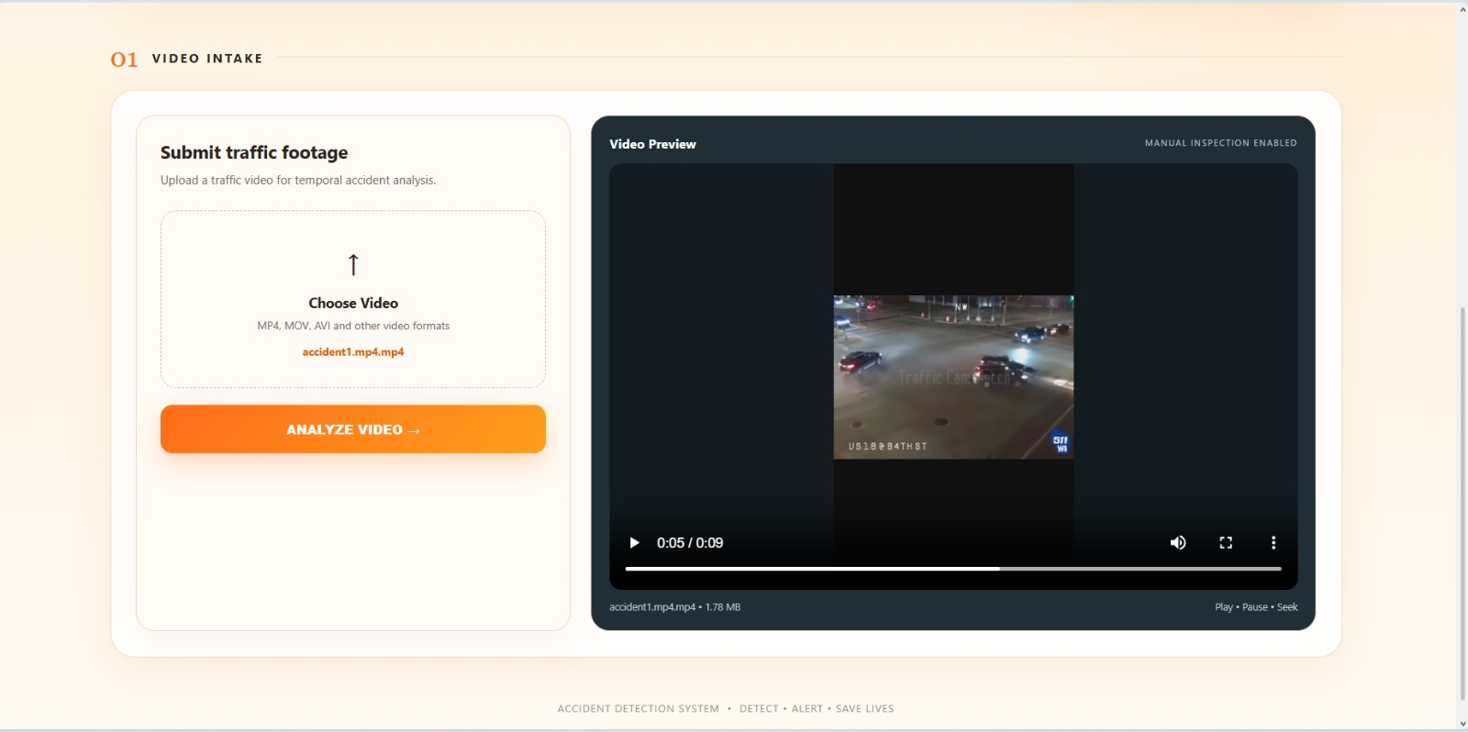

Web interface used for uploading and analyzing traffic videos.

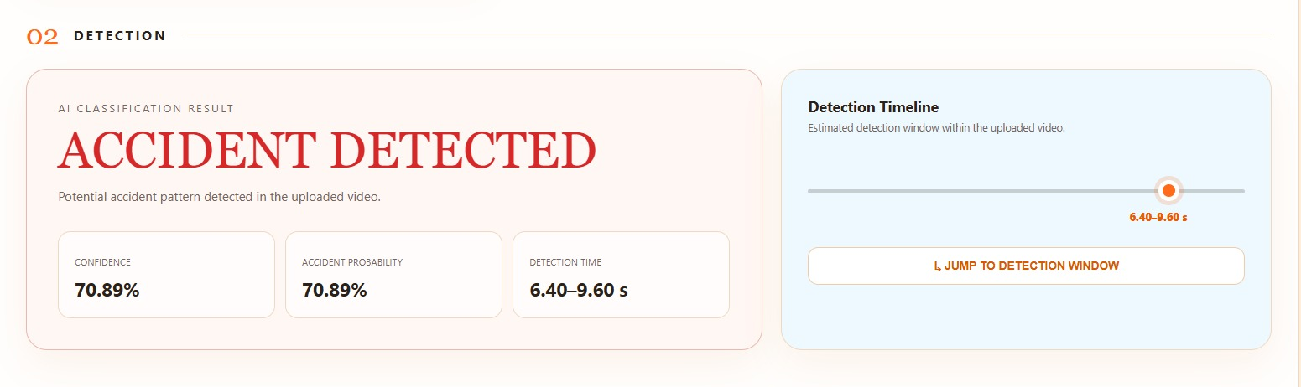
Accident detection result displayed by the system
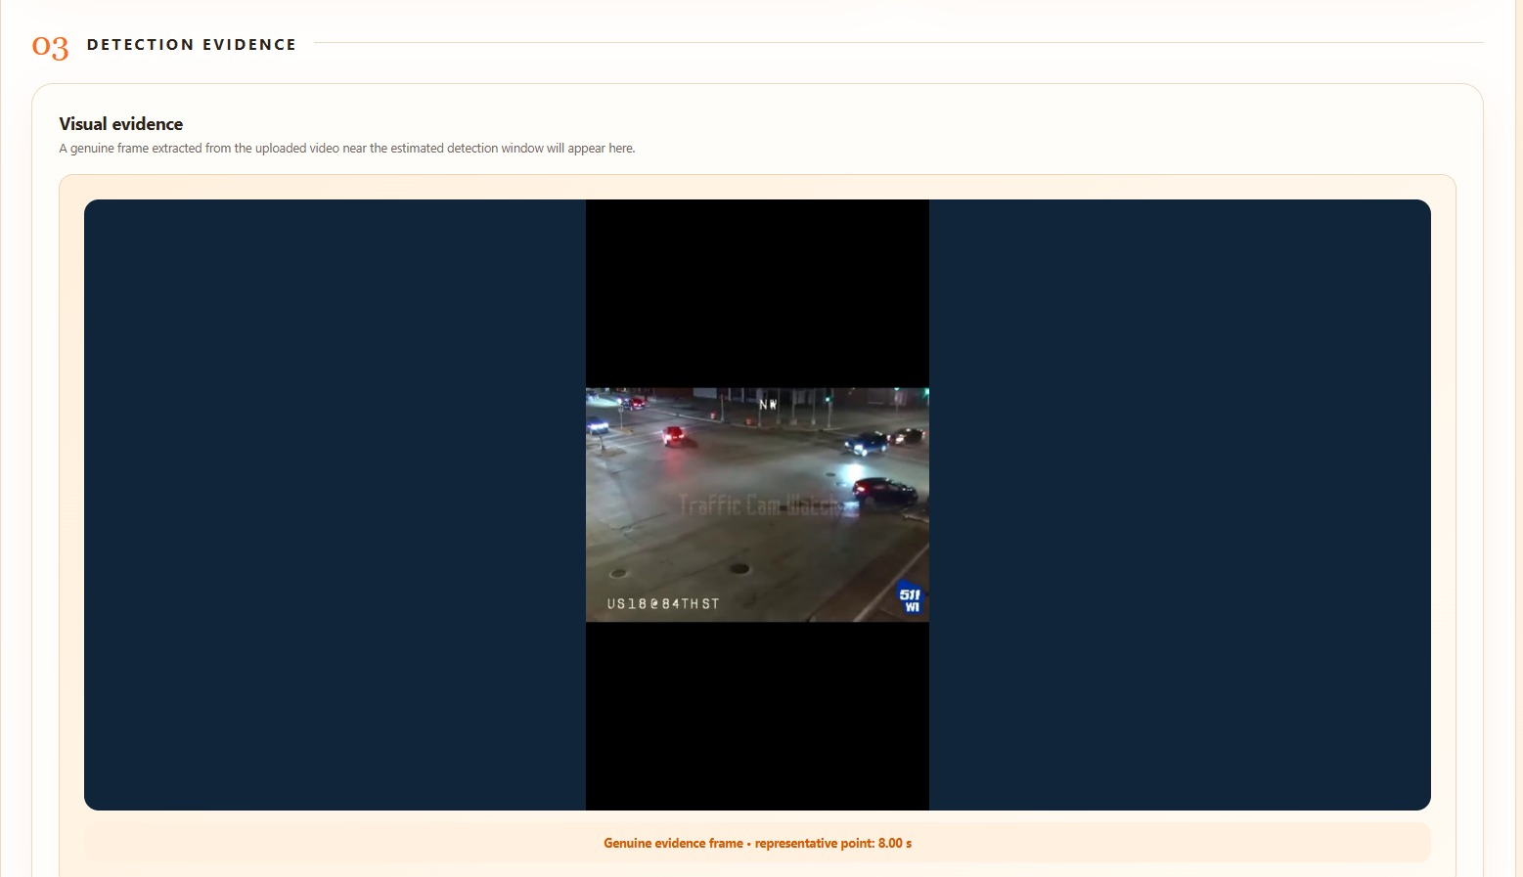
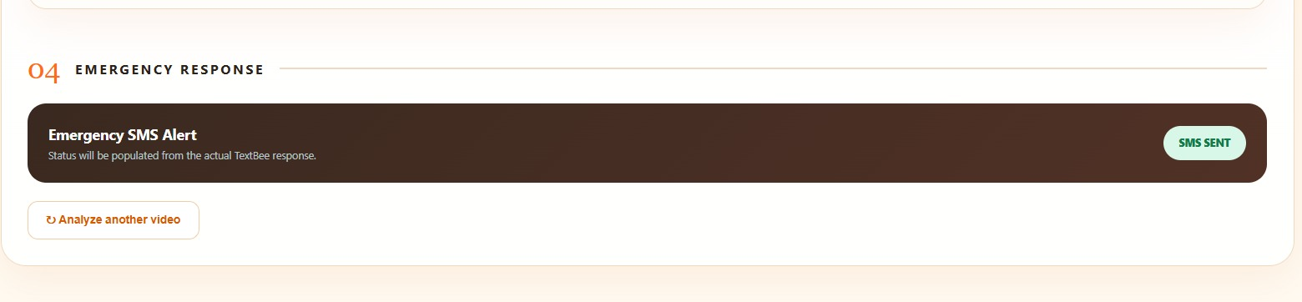 SMS alert generated after accident detection.

